**Swiss Fertility and Socioeconomic Indicators Data (1888) Exploration**

**Author:- Rohan Hadvani**

**Date:- 16/8/2020**

## Introduction

This is the reproducible pitch presentation for the final course porject of Coursera Data Science Specialization Course 9: Developing Data Science Tools. This document will go over the basics of developing the Shiny app. For more information, please see the following links:

1. The Swiss Fertility and Socioeconomic Indicators Data (swiss data) can be accessed with **data(swiss)** in R
2. The GitHub repository containing the R codes required to build the Shiny App (**server.R** and **ui.R**)can be accessed [here](https://github.com/wamber-aww/data-products)
3. The Shiny app can be accessed [here](https://wamber.shinyapps.io/swissdata/), which contains

* Exploring the distribution of each variable in a histogram
* Exploring the relationship of up to three variables in a scatter plot

## The Swiss Data

* Except for fertility, all variables are expressed in the proportions (%) of the population
* Use **?swiss** to read more about the study

data(swiss)

summary(swiss)

## Fertility Agriculture Examination Education

## Min. :35.00 Min. : 1.20 Min. : 3.00 Min. : 1.00

## 1st Qu.:64.70 1st Qu.:35.90 1st Qu.:12.00 1st Qu.: 6.00

## Median :70.40 Median :54.10 Median :16.00 Median : 8.00

## Mean :70.14 Mean :50.66 Mean :16.49 Mean :10.98

## 3rd Qu.:78.45 3rd Qu.:67.65 3rd Qu.:22.00 3rd Qu.:12.00

## Max. :92.50 Max. :89.70 Max. :37.00 Max. :53.00

## Catholic Infant.Mortality

## Min. : 2.150 Min. :10.80

## 1st Qu.: 5.195 1st Qu.:18.15

## Median : 15.140 Median :20.00

## Mean : 41.144 Mean :19.94

## 3rd Qu.: 93.125 3rd Qu.:21.70

## Max. :100.000 Max. :26.60

## Codes for Histogram

inputVar <- 'Fertility'; inputBin <- 10; histVal <- swiss[, inputVar]

hist(histVal, breaks = seq(min(histVal), max(histVal), length.out = inputBin+1),

xlab = inputVar, main = paste('Distribution of', inputVar),

col = 'darkgray', border = 'white')

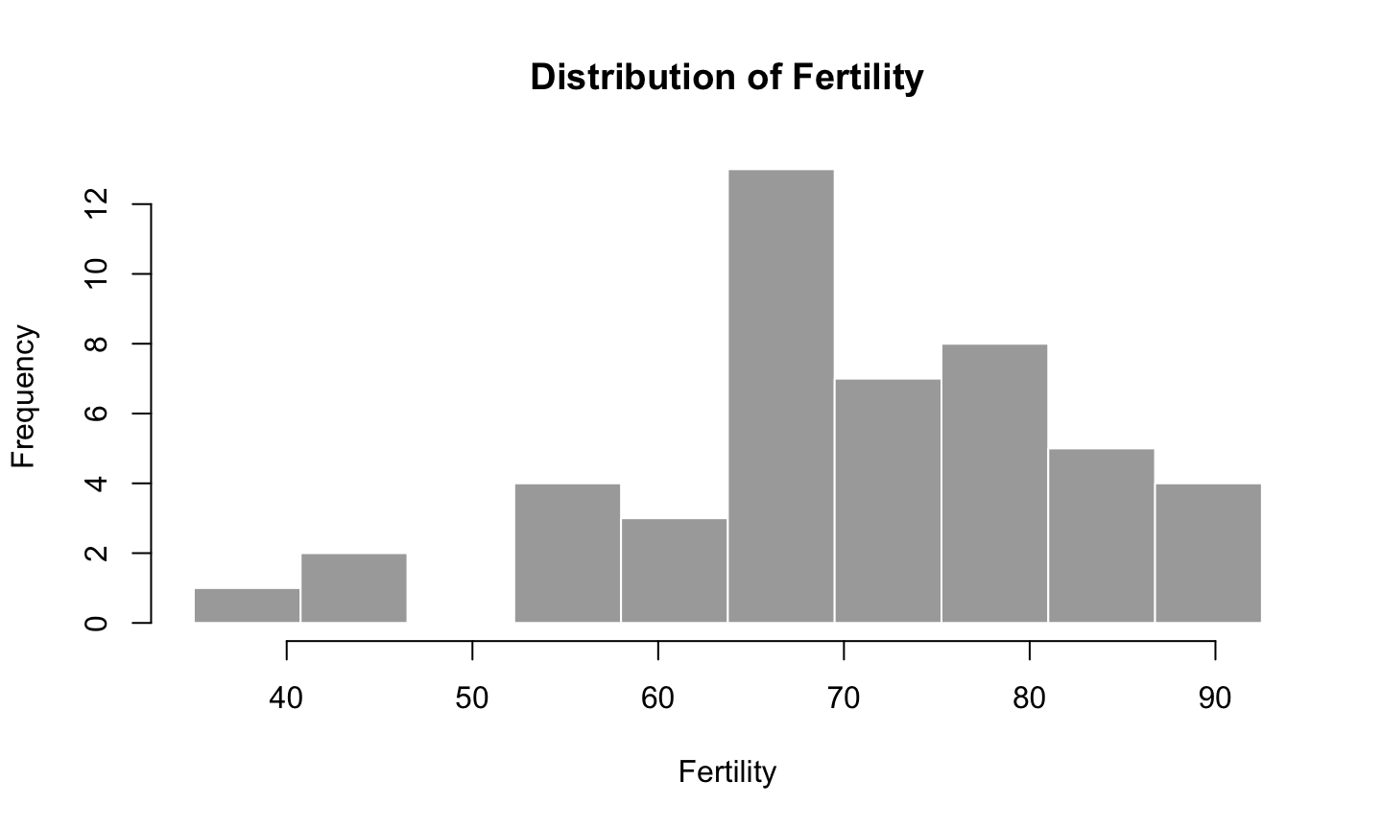

## Codes for Scatter Plot

library(ggplot2)

scatX <- 'Fertility'; scatY <- 'Education'; scatC <- 'Examination'

ggplot(data = swiss, aes(x = Fertility, y = Education, color = Examination)) +

geom_point() + xlab(scatX) + ylab(scatY) + labs(colour = scatC) +

ggtitle(paste('Scatter plot of', scatX, 'vs', scatY)) +

theme(plot.title = element_text(hjust = 0.5))

